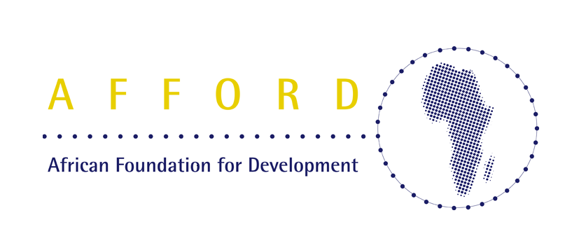

An overview of AFFORD
Formed in 1994, AFFORD's mission is to expand & enhance the contribution that Africans in the diaspora make to Africa's development. AFFORD is transforming itself into a social enterprise & embracing entrepreneurial ways of working.

AFFORD’s values are encapsulated by a determination to be facilitator & catalyst for Africa’s:

- Self-determination
- Self-help
- Self-reliance
- Self-respect
- Self-confidence

AFFORD’s five strategic goals

- Shift the balance of power to Africa
- Influence the African development agenda
- Strengthen AFFORD’s legitimacy & effectiveness
- Build a strong & sustainable organization
- Root AFFORD firmly in Africa.

AFFORD’s SMART objectives, 2005-2008
- Enhance 40 Africa-based & African diaspora organizations’ & individuals’ capacity to sustain/support enterprise in Africa through diaspora linkages
- Establish/support institutional linkages & policies that sustain diaspora engagement for enterprise development in three African countries & UK
- Enhance public awareness in the UK & at least three African countries of African agency & African-led/owned development efforts
- Grow public support for AFFORD as a model of African agency
- Increase AFFORD’s autonomy to pursue its own agenda.

AFFORD’s current & future projects
- African Diaspora & Development Day (ad3): Annual event & related activities that bring together hundreds of African diaspora groups & individuals & others interested in Africa around ways of maximizing the diaspora’s contribution to Africa’s development
- Opportunity Africa: Supporting young Africans to realize their career aspirations in ways that benefit them & Africa (includes internships in Africa)
- Helping Africans Influence London (HAIL): Advocacy training & support to help Africans in London influence policies that enable them to integrate & contribute to development in their regions of origin
- Mobilizing African Home & Diaspora Resources for Enterprise in Africa (MAHDREIA): Development of resource pools of people – entrepreneurs, experienced managers, trainers, etc – among Africans in the diaspora & counterparts in Africa to provide direct & long-distance business support – skills training, mentoring & coaching, business planning, advice, investment, access to contacts – to grassroots entrepreneurs to scale up their business ventures & create more jobs.
- PEWA Awards (People Earnestly Working for Africa): Peer-based awards recognizing the contributions that African diaspora groups & individuals make to Africa’s development
- Step-by-Step Walkathon: Sponsored event that enables African diaspora organizations to mobilize their supporters & raise funds for their work in Africa
- ROADS (Releasing Our African Diaspora Stories): Project to put African diaspora initiatives in the public spotlight to raise awareness of “African agency” & celebrate success
- Enterprise Africa Resource (EAR): Resource centre & support to African diaspora groups & individuals to enable them to mobilize their resources to support enterprise & job-creation for young people in Africa
- CHAMPION: Centre in Africa to enable grassroots communities to “pull in” resources they require from diaspora counterparts
- Rich Picture: Interactive website resource to enable African diaspora groups to understand how their resource mobilization efforts can help create lasting change in Africa & who they can partner with to achieve shared objectives.

Some recent AFFORD achievements
- We have helped build the capacity of over 100 African organizations in the UK working for Africa’s development through hands-on advice, training, networking & support as well as by leveraging in the resources of established second-tier capacity building support agencies
- Over the past 11 years AFFORD has helped shaped the debate about the role of diaspora groups supporting development in their regions of origin, first helping to set the agenda & later to help shape & inform policy around this area
- We have established the annual African Diaspora & Development Day (ad3) as a major event that brings together several hundred Africans & friends of Africa to explore ways that the African diaspora can maximize their contributions to Africa’s development
- We have supported the creation & growth of two diaspora umbrella bodies, Connections for Development (CfD) & African Diaspora Voices for Africa’s Development (ADVAD)
- We have supported over 100 young Africans in London through a careers program that has enabled them to sharpen their focus on Africa-related career opportunities. About five have secured jobs as a direct result of the project & four have secured internship opportunities in Africa
- We established Step-by-Step Walkathon for Africa to enable African diaspora organizations to mobilize their supporters & raise unrestricted income for work in Africa
- We have established the People Earnestly Working for Africa (PEWA) awards to raise the profile & visibility of the African diaspora’s contribution to Africa’s development
- Through our growing consultancy practice we have recently helped the Greater London Authority & the Department for International Development develop diaspora engagement strategies to fulfill their respective remits.

Contacting AFFORD…
AFFORD (African Foundation for Development)
Ground Floor, 31/33 Bondway, London SW8 1SJ, UK

t: +44 (0)20 7587 3900 f: +44 (0)20 7587 3919
e: afford@afford-uk.org w: http://www.afford-uk.org

